1 This project involves using your Pi to read data from a RFID sensors. This sensor designed to read data from Radio Frequency Identification tags.

! This involves creating electrical circuits and connections and a bit of soldering. We recommend this is done under the guidance of a mentor or parent.

2 The reader can be purchased as a (Mifare) RC522 kit. The reader kit will require a bit of soldering if you want to use the pin connectors for jumper wires.

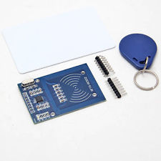

3 The wiring should follow this pattern. The board uses the SPI interface, be careful not to reverse the MOSI and MISO lines!

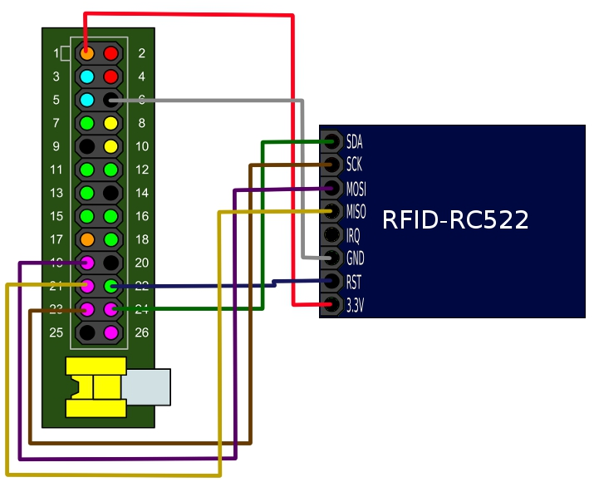

4 The kit uses the SPI protocol for communication. We need to enable this on the Pi by editing the following file

**$ sudo nano /etc/modprobe.d/raspi-blacklist.conf**

Comment out the line containing this entry:

**spi-bcm2708 blacklist**

*Now reboot your Pi.*

5 Now we need to get python library which supports SPI. This is available from this repository

$ git clone https://github.com/lthiery/SPI-Py

then change to the SPI-Py directory and install the software:

$ sudo python setup.py install

6 Now we need a library for the NFC 522 reader. This is available from this repository

$ git clone https://github.com/mxgxw/MFRC522-python

Then change to the MFRC522-python folder and execute the test program

S sudo python MFRC522.py

7 Now test the output by holding up a RFID tag to the reader. Your program should detect the data on the tag!

More information on how to complete this project is at:

<https://www.raspberrypi.org/documentation/hardware/raspberrypi/spi/README.md>

<http://fuenteabierta.teubi.co/2013/07/utilizando-el-lector-nfc-rc522-en-la.html>